**Lab String (Day-8)**

1. **Write a Python program to count the occurrences of each word in a given sentence. string = “To change the overall look of your document. To change the look available in the gallery”.**

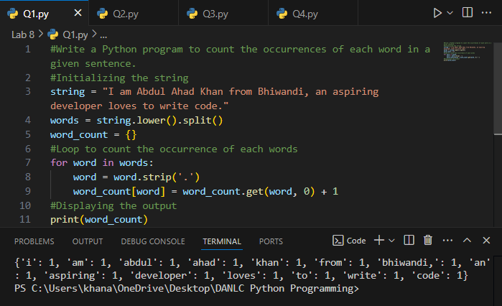

1. **Write a Python program to remove a newline in Python.**

**String = "\nBest \nDeeptech \nPython \nTraining\n".**

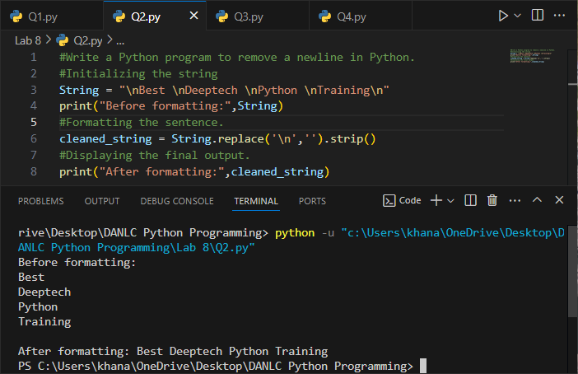

1. **Write a Python program to reverse words in a string.**

**String = “Deeptech Python Training”.**

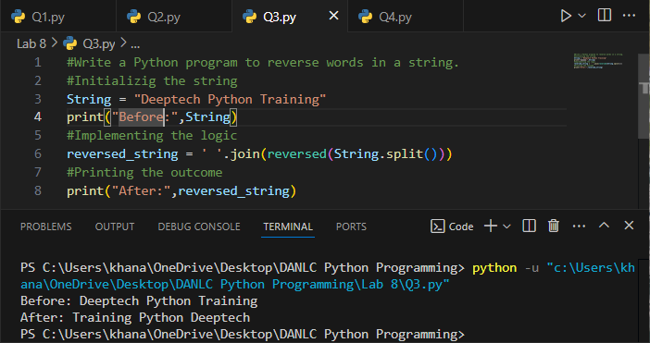

1. **Write a Python program to count and display the vowels of a given text.**

**String=”Welcome to python Training".**

